**Digital Assignment 2**

**Devang Mehrotra**

**18BCE0763**

Q1- Write a python program to

1. 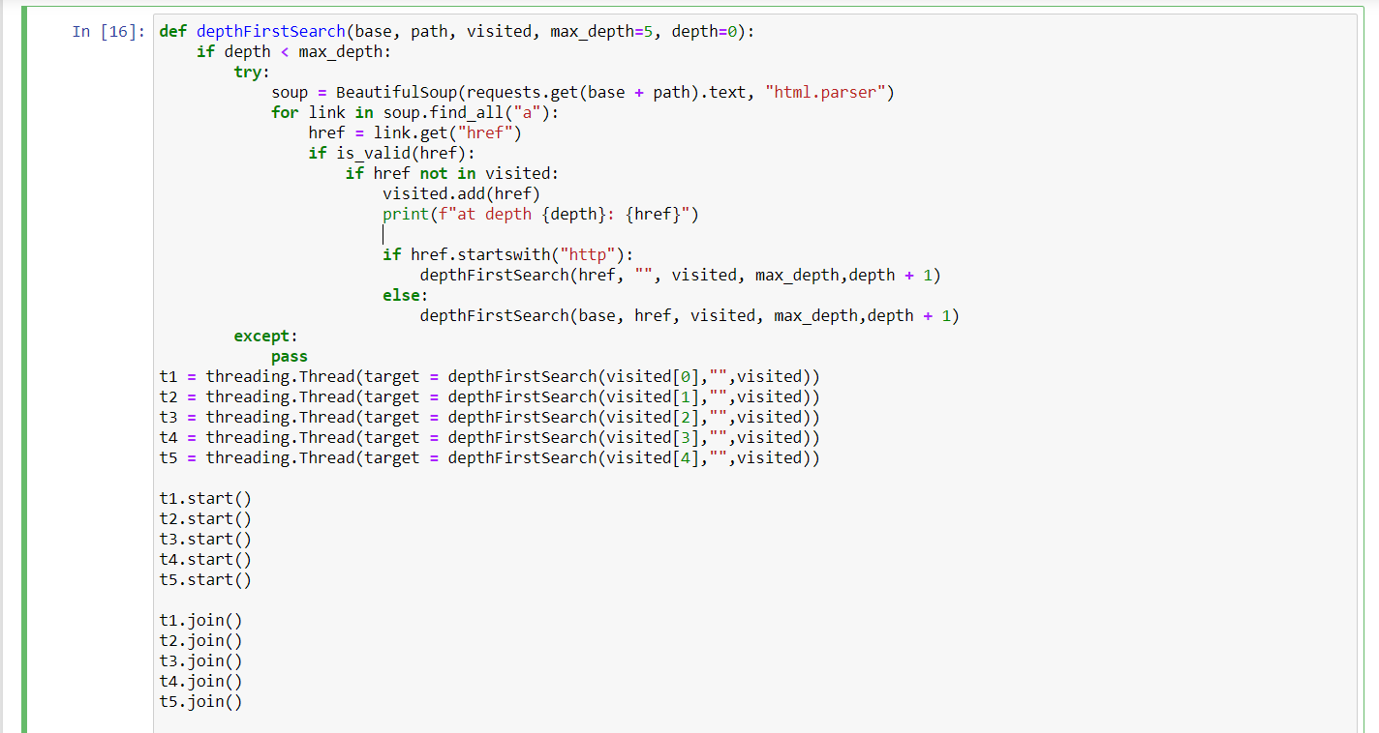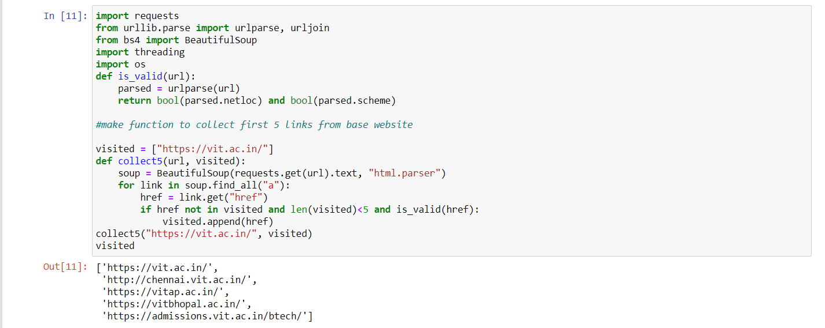show the implementation of a concurrent depth-first crawler (No. of threads = 5 and depth =5).

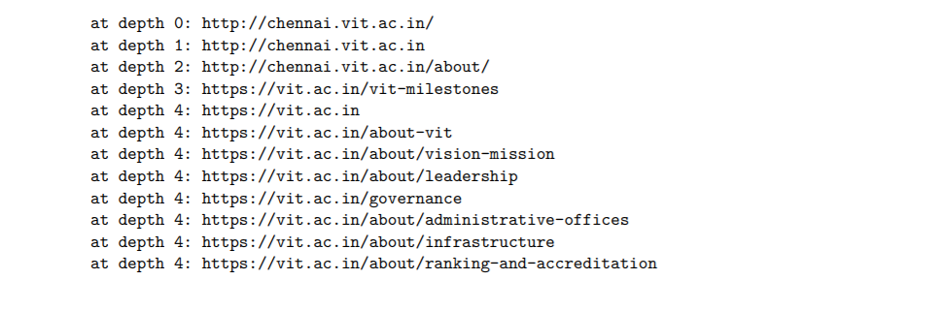**Output-**

1. 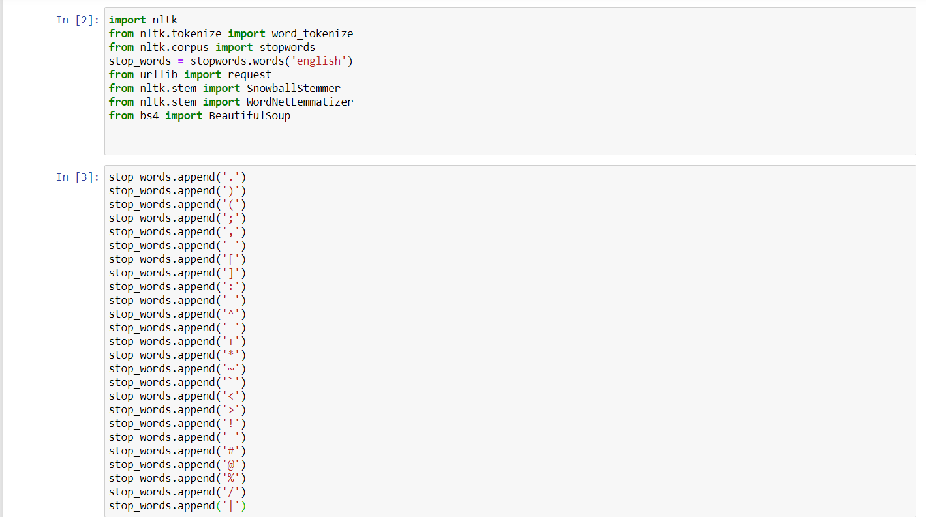Develop the crawler program to handle various challenges (such as Parsing, Stemming, Lemmitization, Link Extraction, Canonicalization, Spider Trap etc.) faced by crawler while implementing.

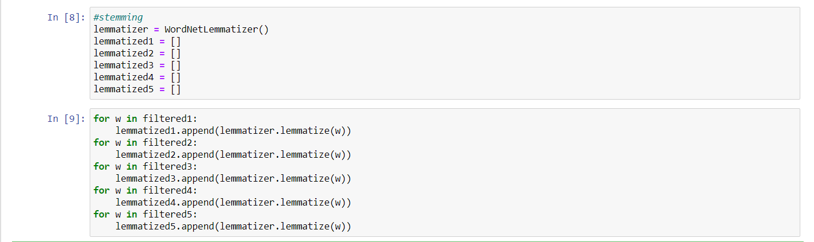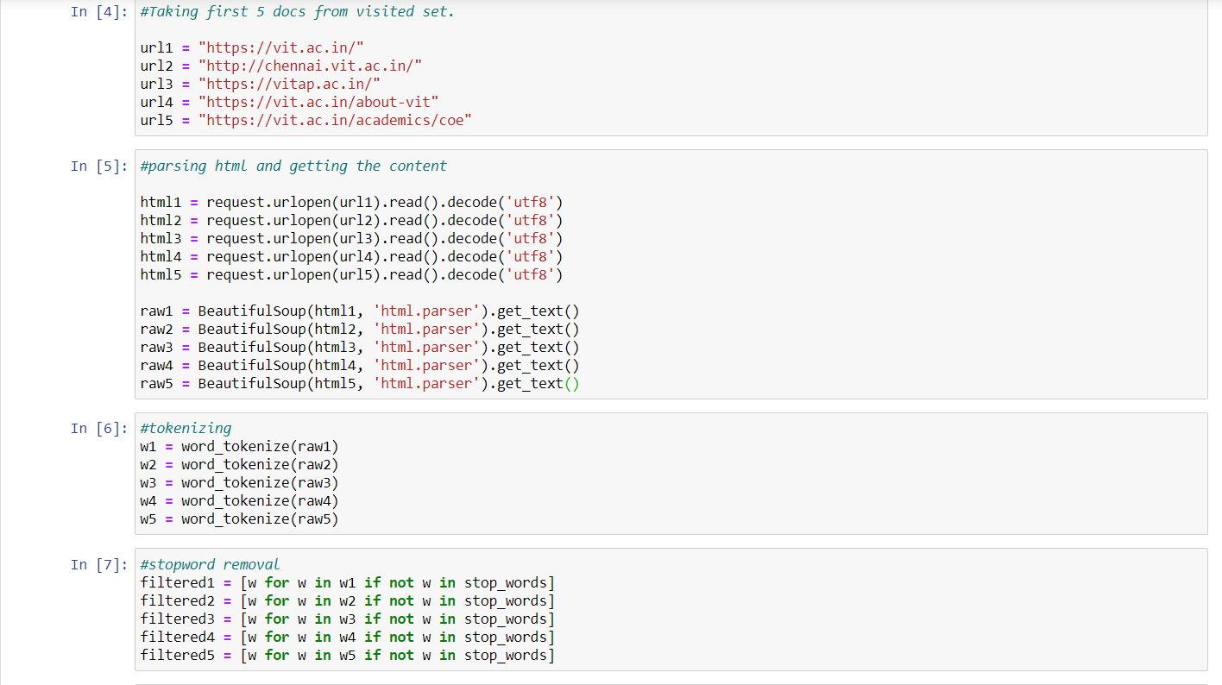

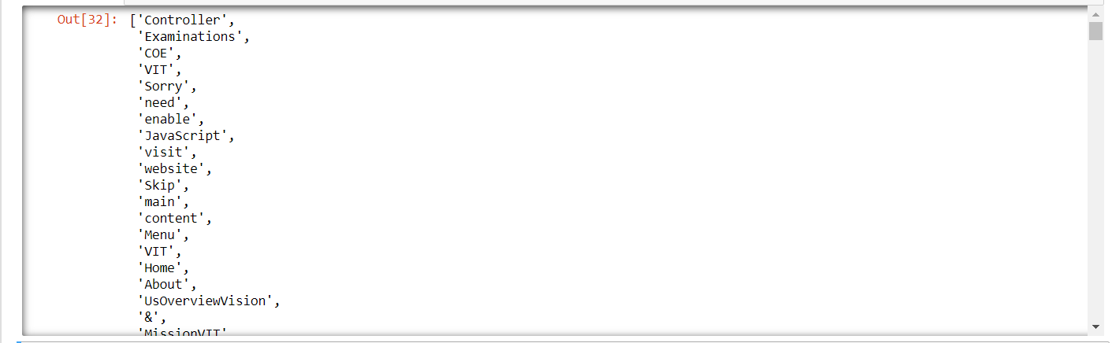**Output-**

1. Based on the contents retrieved, prepare one inverted index file (with proper representation).

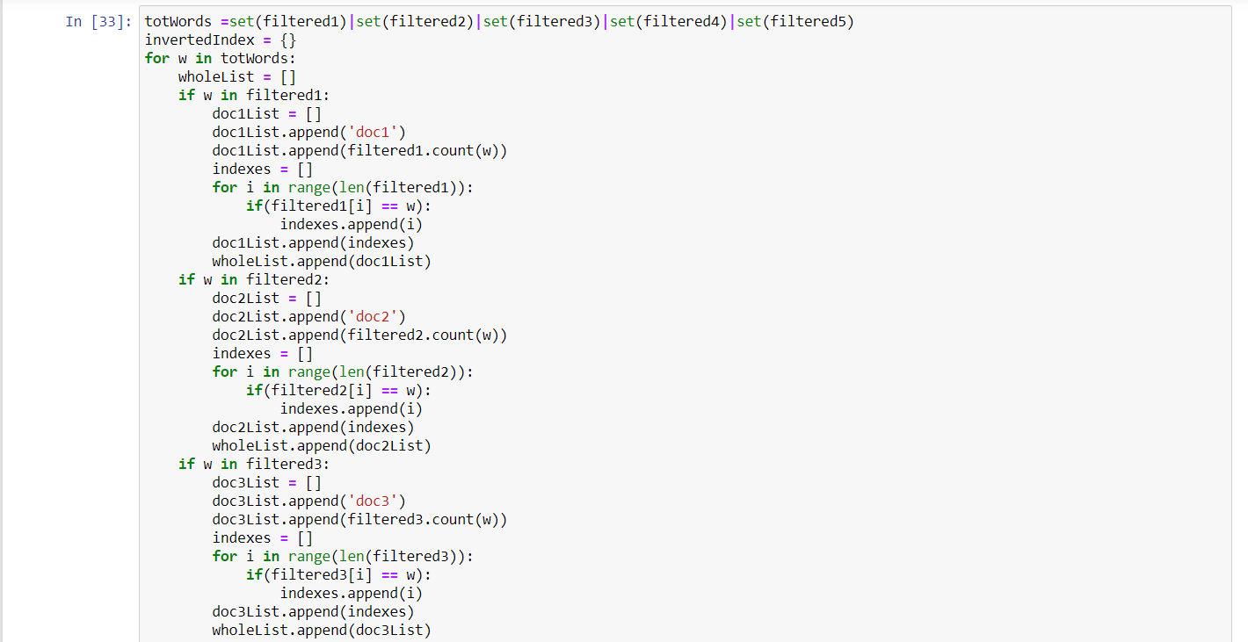

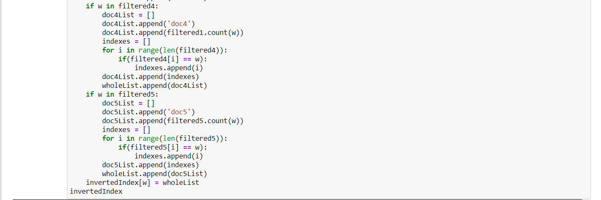

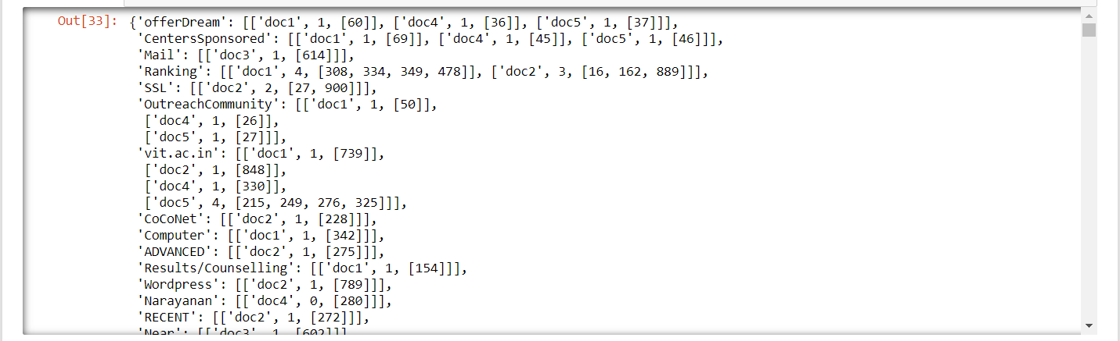**Output-**

Q2- Write a python program to show the implementation of Golomb Encoding-decoding technique.

1. 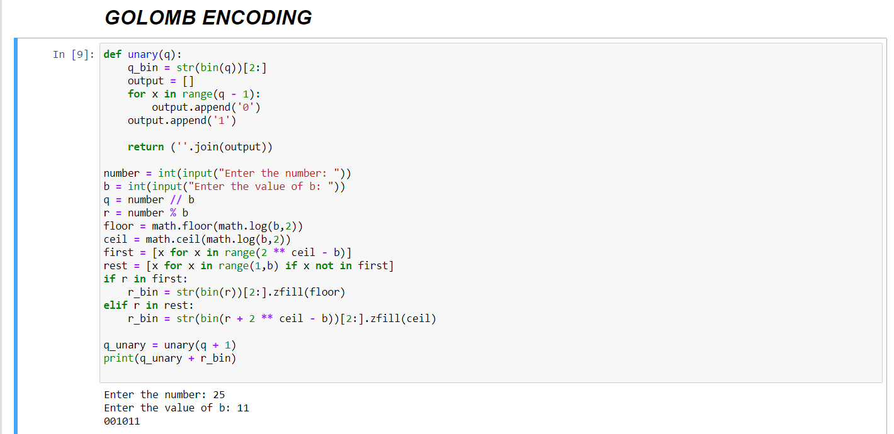Encode x=25, 37, with b=11 and b=16.

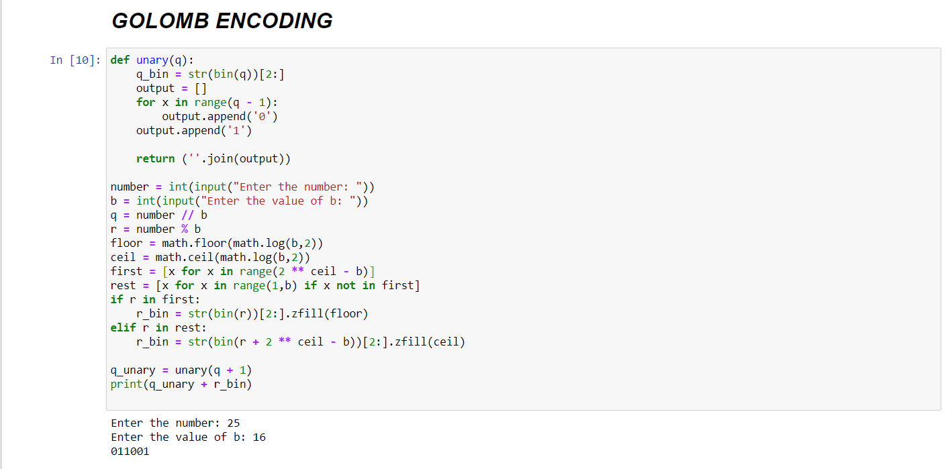

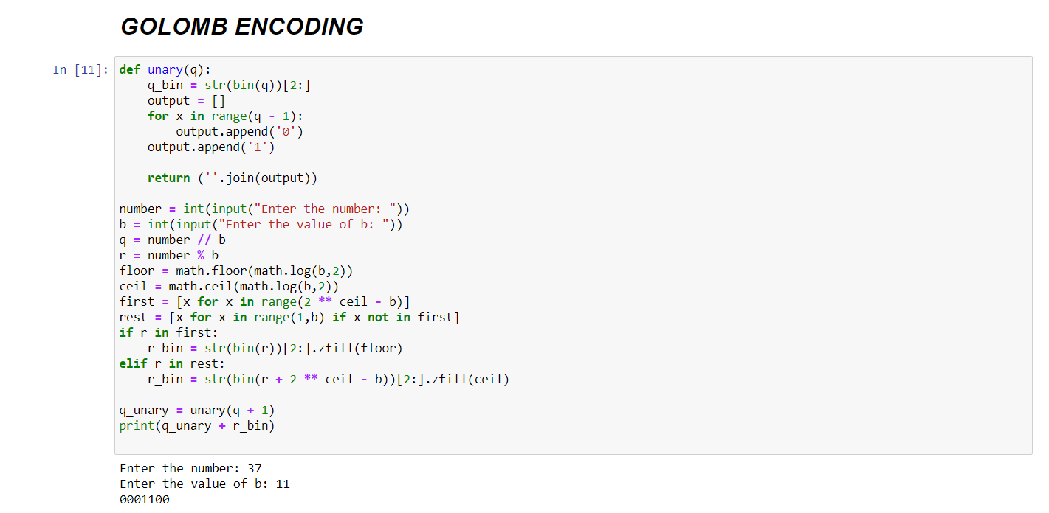

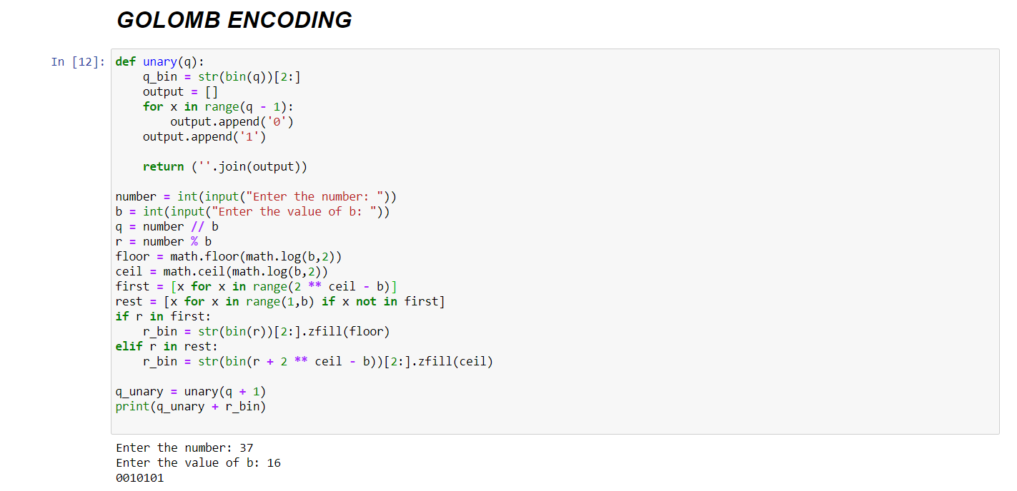

1. 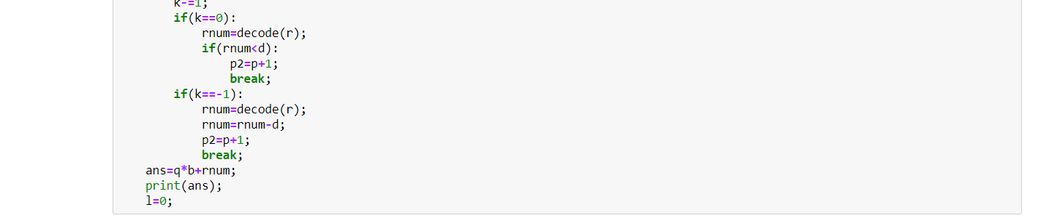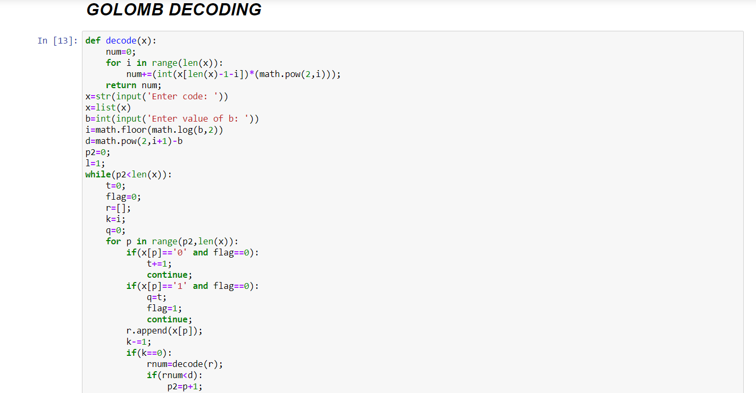Decode the Golomb encoded sequence 1111111110010001101 with b = 10.

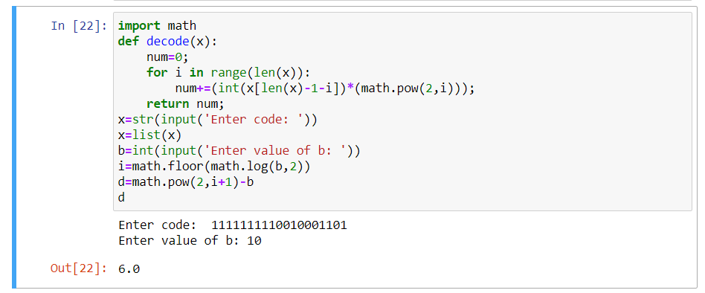**Output-**

Q3- Write a python program to extract the contents (excluding any tags) from two websites

<https://en.wikipedia.org/wiki/Web_mining>

https://en.wikipedia.org/wiki/Data_mining

Save the content in two separate files. Construct a trie based on the content retrieved in using HashMap / B-Tree / Dictionary. Write a program to show the implementation of Predictive Typing and Auto-Correct using the trie prepared.

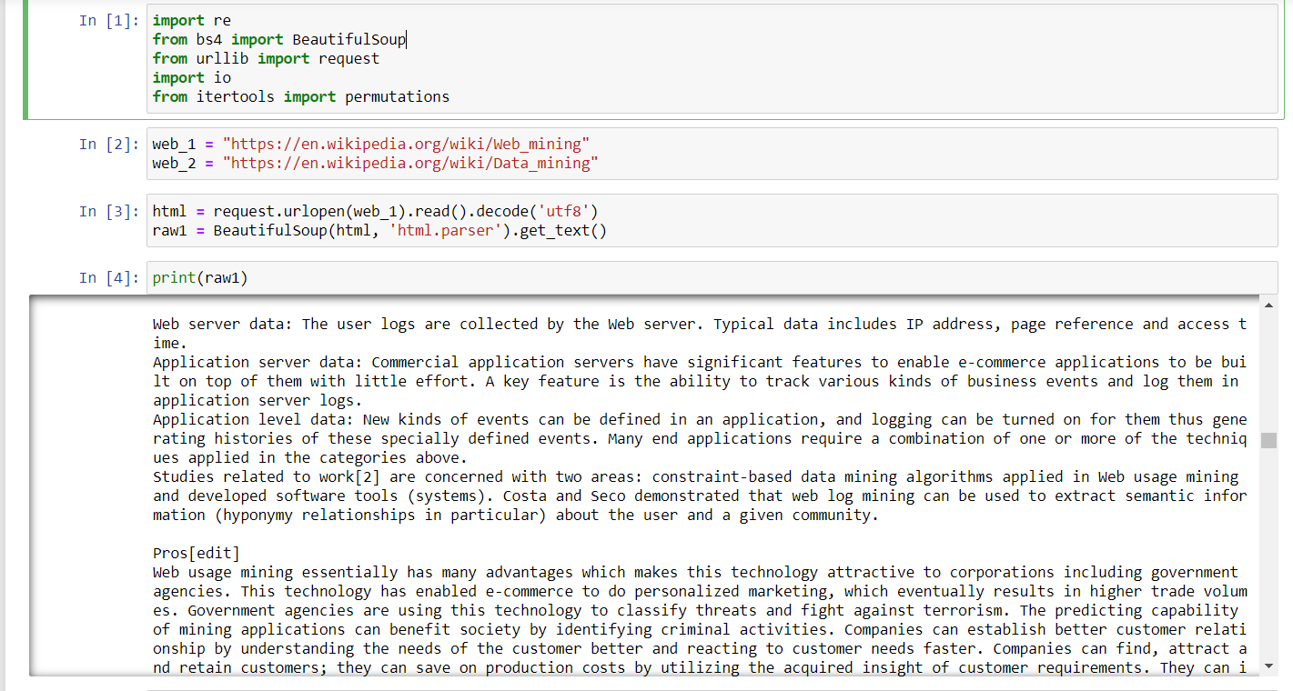

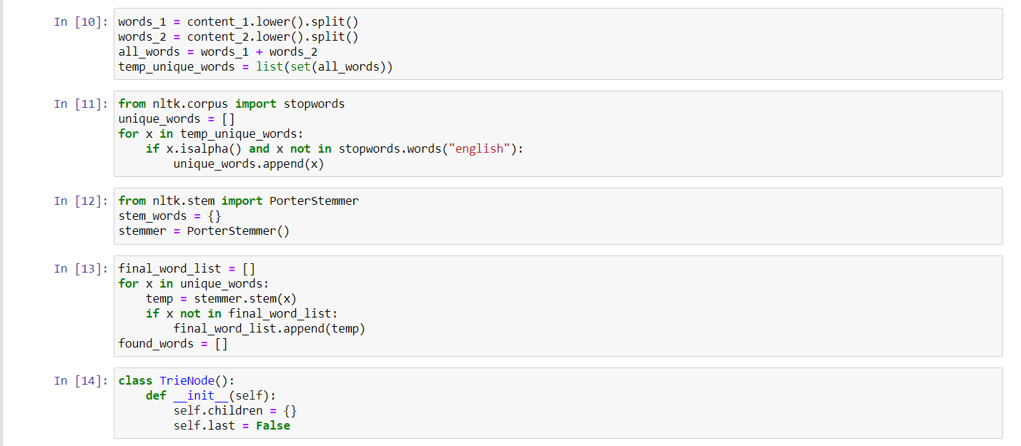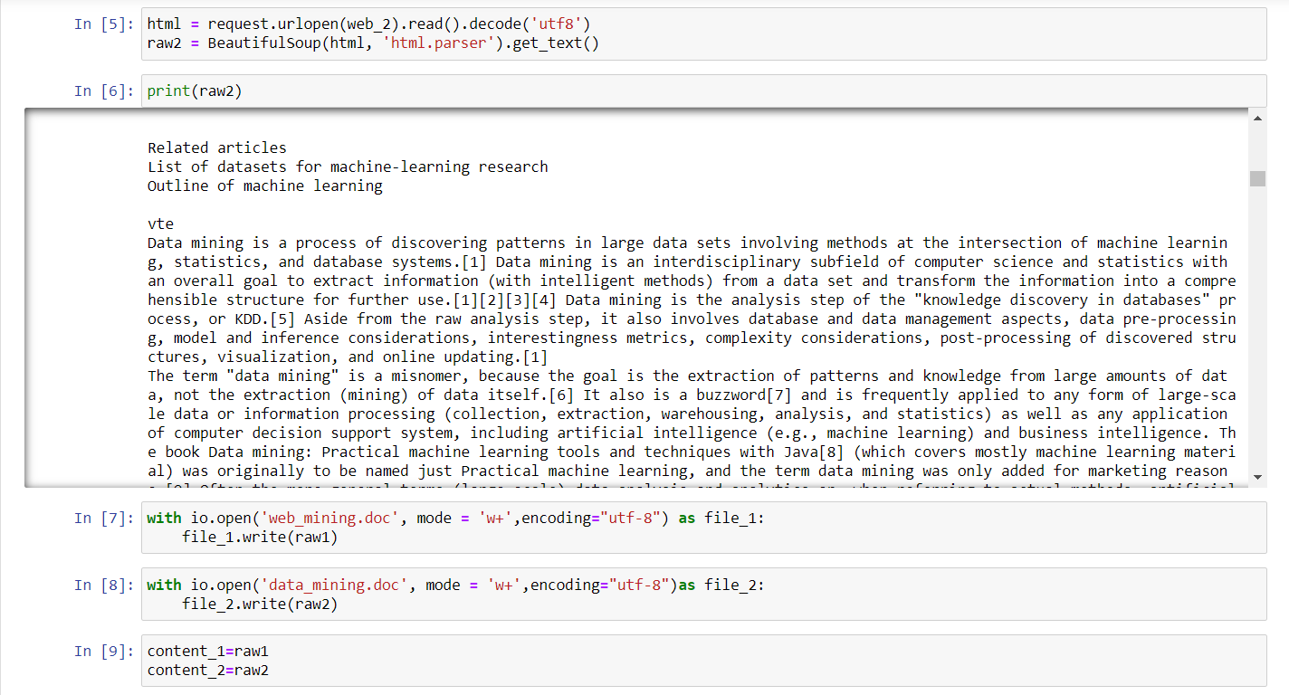

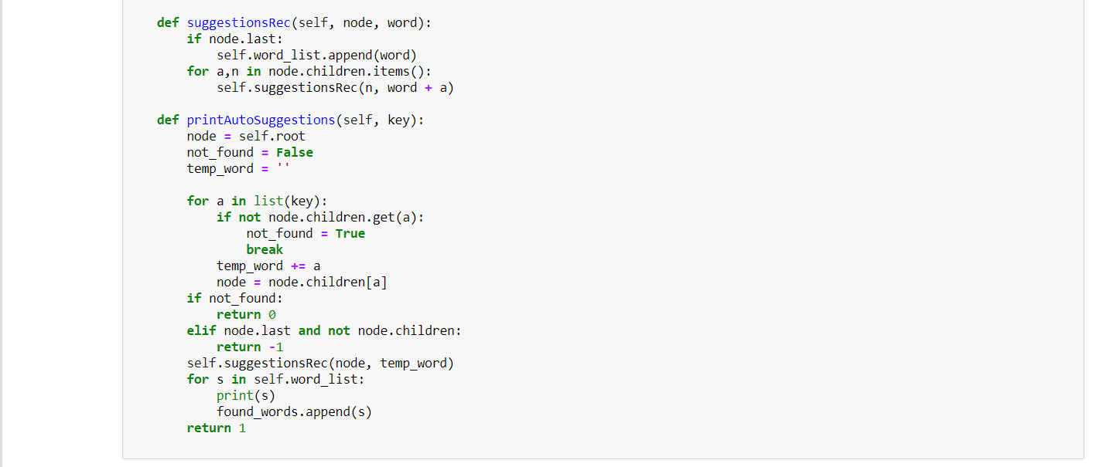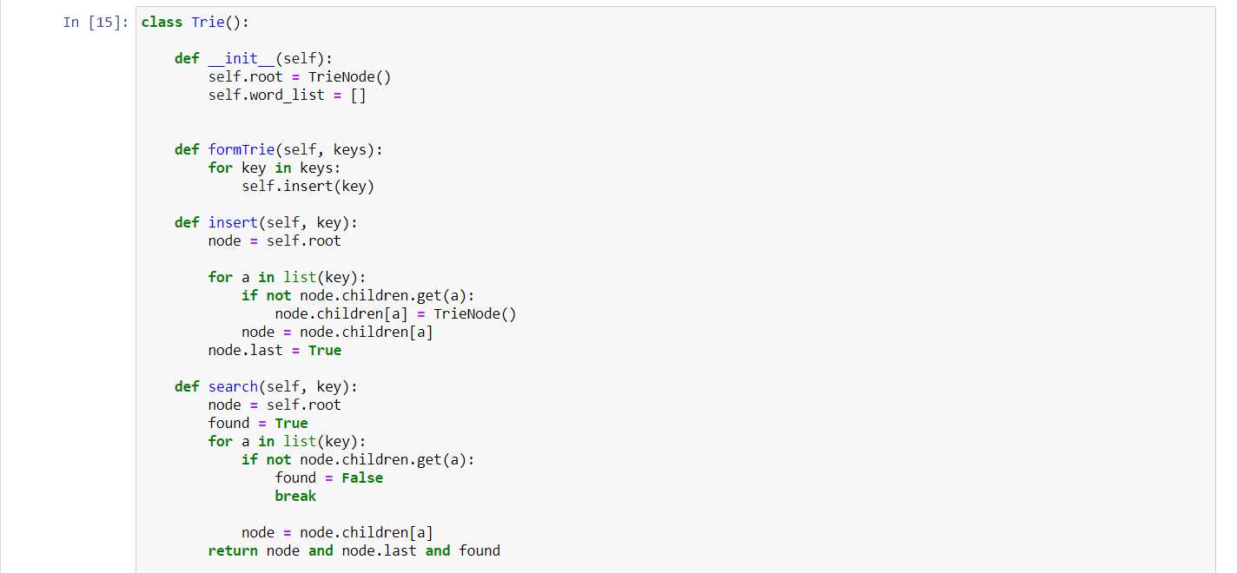

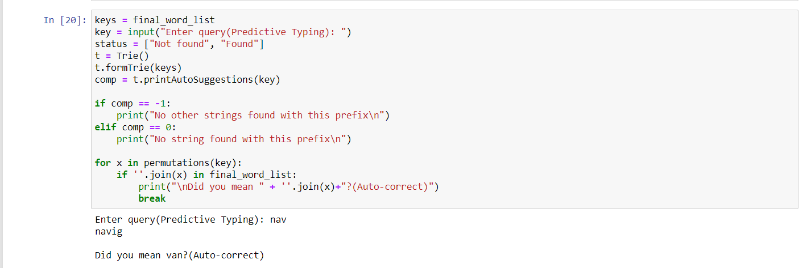**Output-**

Q4- Write a python program to extract the contents (excluding any tags) from the following five websites

<https://en.wikipedia.org/wiki/Web_mining>

<https://en.wikipedia.org/wiki/Data_mining>

<https://en.wikipedia.org/wiki/Artificial_intelligence>

<https://en.wikipedia.org/wiki/Machine_learning>

<https://en.wikipedia.org/wiki/Mining>

Refined the contents by applying stopword removal and lemmatization process. Save the refined tokenized content in five separate files. Considering a vector space model and do the following operations according to the query “Mining large volume of data”.

* Bag-of-Words (Document corpus)
* TF (Document corpus)
* IDF (Document corpus)
* TF-IDF (Document corpus)
* TF-IDF (Query)
* Normalized (Query)
* Normalized - TF-IDF (Document corpus)
* Cosine Similarity
* Euclidean Distance
* Document Ranking (Display Order)
* 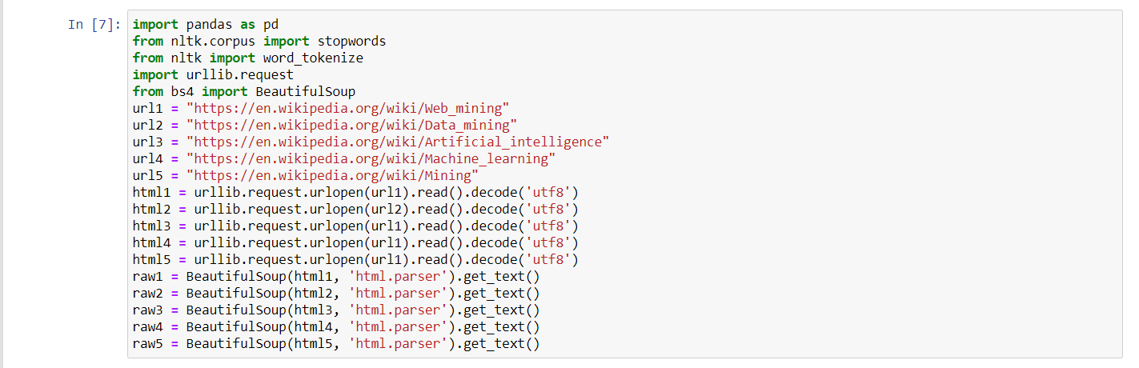Document Similarity (Among Documents)

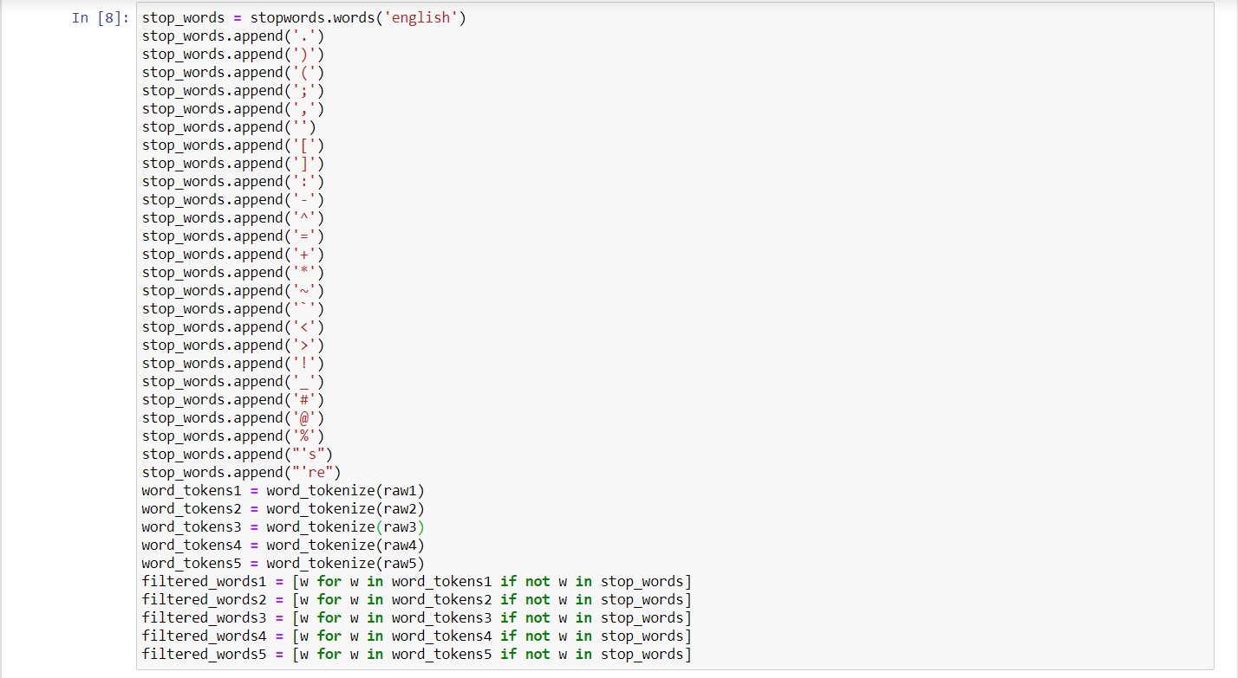

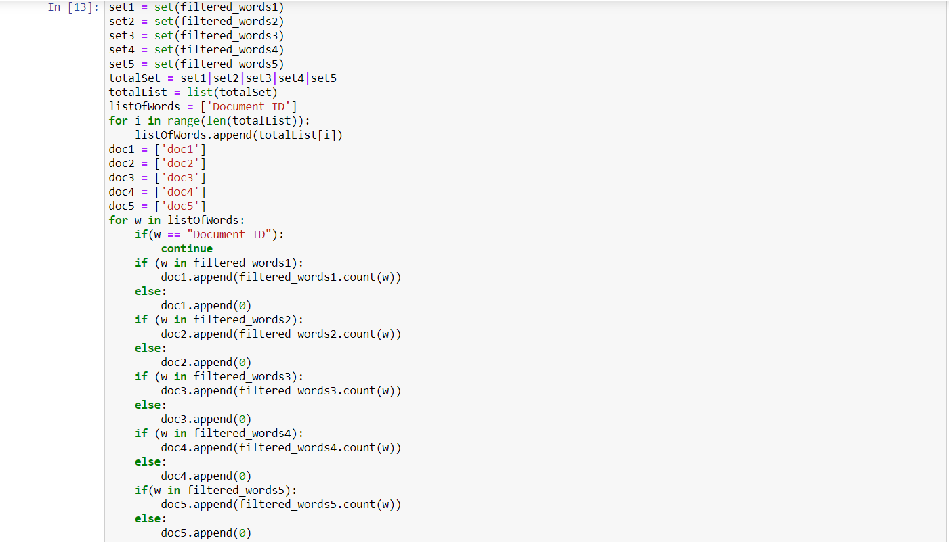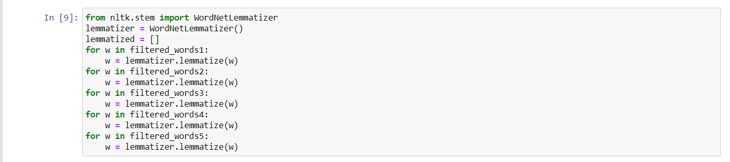

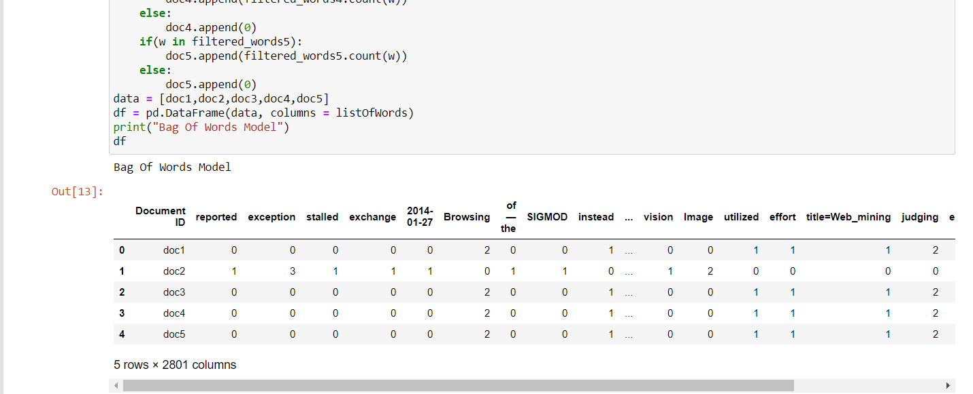**Output-**